Institute of Computer Technology

B. Tech. Computer Science and Engineering

Sub: DS Branch: BDA Class: A

Name: Jatin Patel

Enrolment No.: 23162121029

Sem: 3

Class: A

Subject: DS

Practical: 01

Date: 31/07/24

Practical: 01

1. Gross Salary Problem In a company an employee is paid as under:

Along with the basic salary, the employee would be given dearness allowance of 40% of his basic salary and house rent allowance of 20% of his basic salary. If the basic salary of an employee is received as input, write a program to find his/her gross salary.

Input:

Take basic Salary as input Output:

Output the gross salary. Example

Input:

1203

Output:

1924.800049

Input:

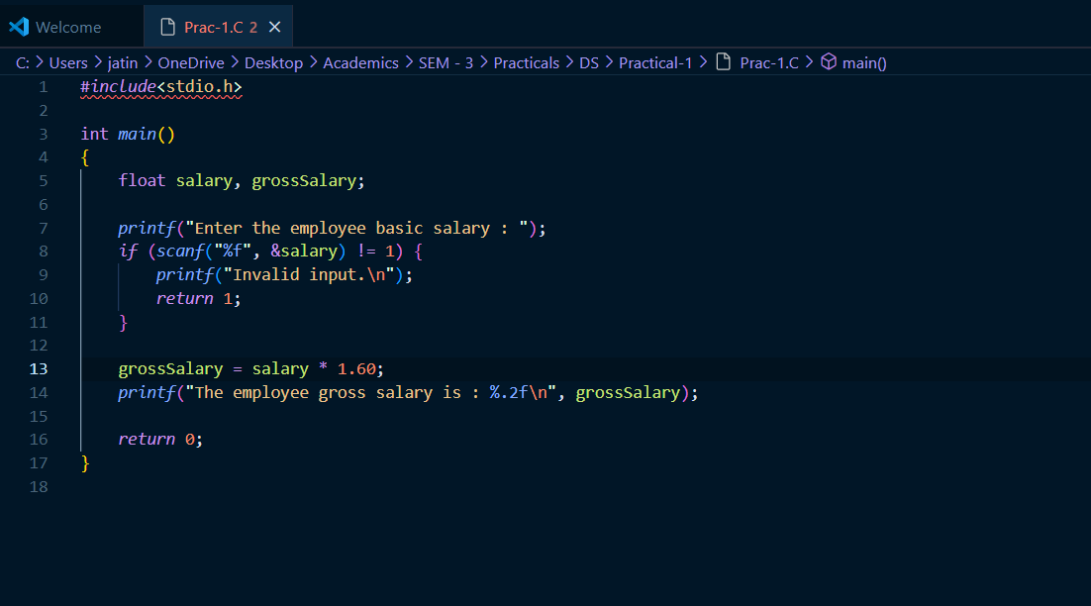

Output:

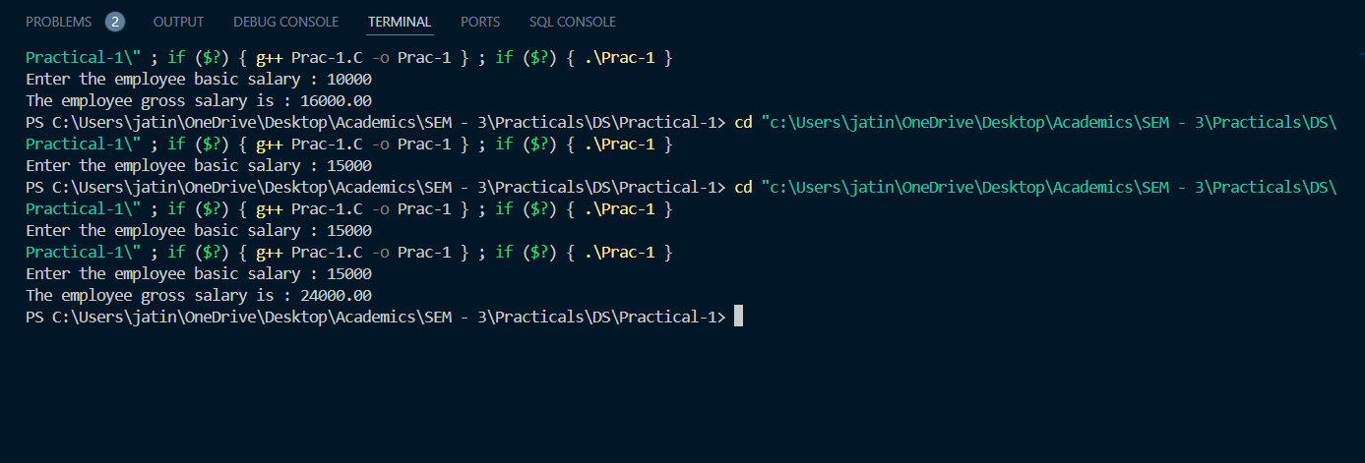

2. Conversion Problem The distance between two cities (in km.) would be given by the user. Write a program to convert and print this distance in:

1. Feet.

2. Meters.

3. Inches.

4. Centimeters.

Input:

The input for the code would contain the distance between two cities in kilometers. Output: The

distance in each of the mentioned units.

Example:

Input: 50

Output:

Feet: 164042.000000

Meters: 50000.000000

Inches: 1968505.000000

Centimeters: 500000.000000

Input:

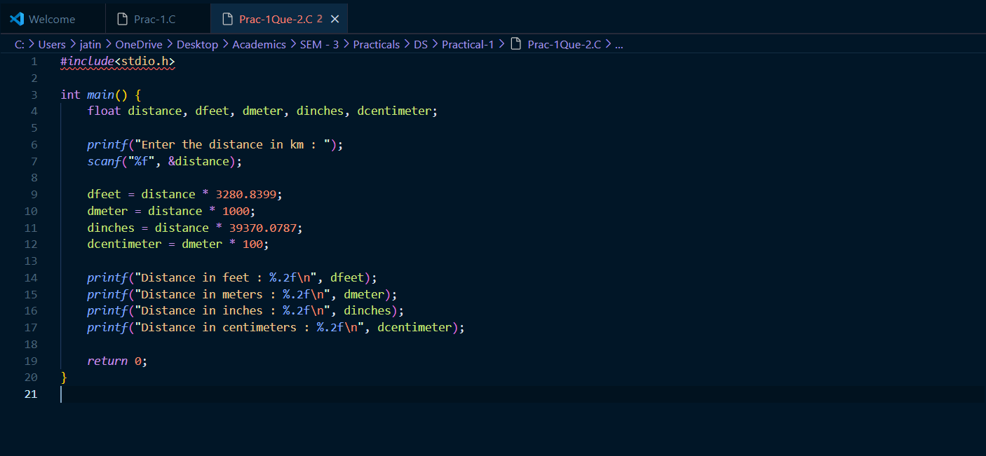

Output:

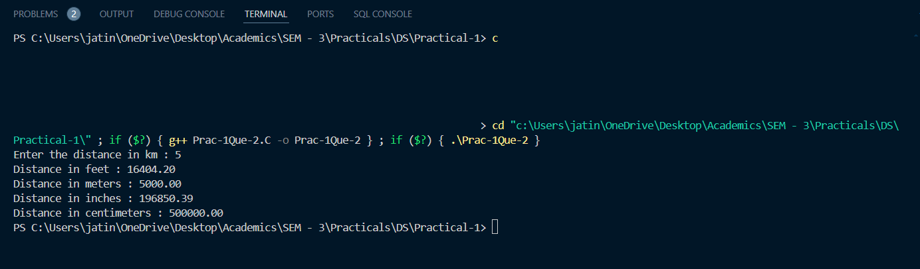

3. Marks Calculator A student enters his/her marks of 5 subjects in a program.

Assume that the maximum marks that can be obtained by a student in each subject to be 100. Write a program to calculate the aggregate marks of the student. Also, calculate the percentage marks obtained by the student.

Input:

Marks of 5 Subjects separated by spaces. Output:

Aggregate Marks on the first line. Percentage on the second line.

Example:

Input:

60 76 88 68 90

Output:

Total: 382

Percentage: 76.400002

Input:

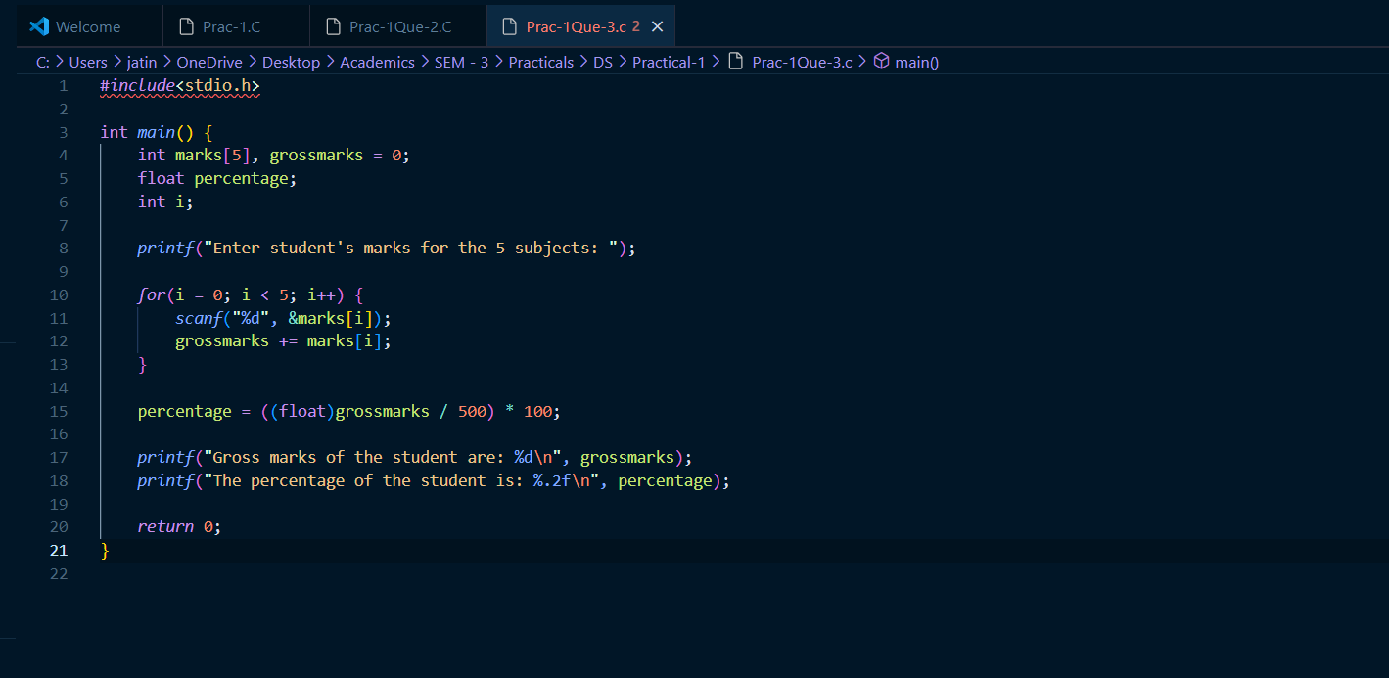

Output:

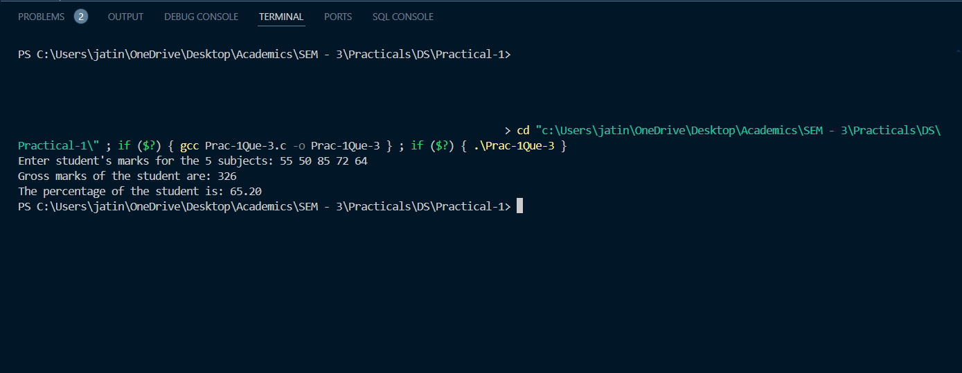

4. Sum of Digits: The user will enter a four-digit number. Write a program that calculates the sum of its digits. (Hint: Use the modulus operator ‘%’).

Input:

Four-digit number.

Output:

Sum of the four digits.

Example

Input: 1234

Output:

10

Input:

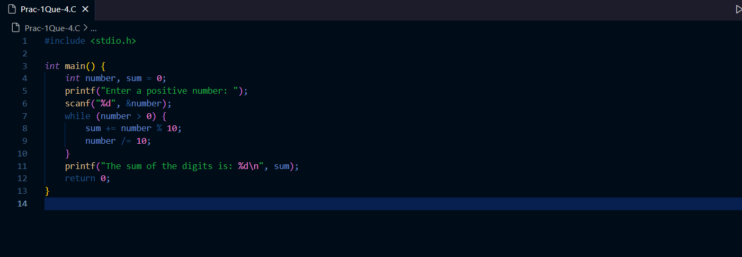

Output:



5. Decrementing Digit Problem Suppose a five-digit number is input by a user. Write a program to print a new number by subtracting one to each of its digits. For example if the number that is input is 12391 then the output should be displayed as 01280.

Input:

Five-digit Number. (12391) Output:

Number with each entry of digit decremented by 1. 1 -&gt; 0

2 -&gt; 1

3 -&gt; 2

9 -&gt; 8

1 -&gt; 0

Example:

Input: 12391

Output: 01280

Input: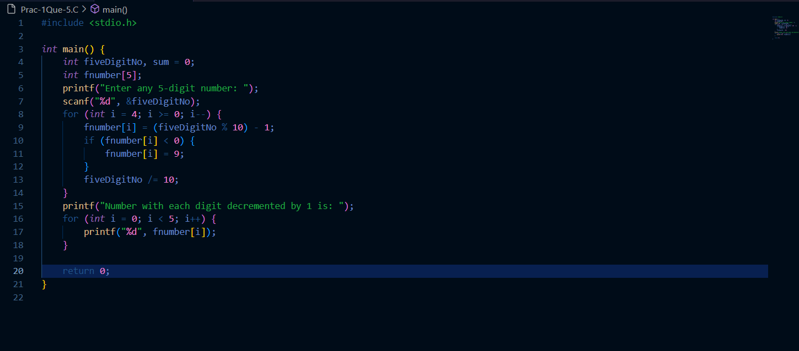

Output: